Symmetric Zigzag Shapes
# Source: AI Source: Provided by: [Data Path: Persons Table -> ID Column: 1, Name_En Column: Motasem Essam] -> From: [ChatGPT] on [7/25/2026]
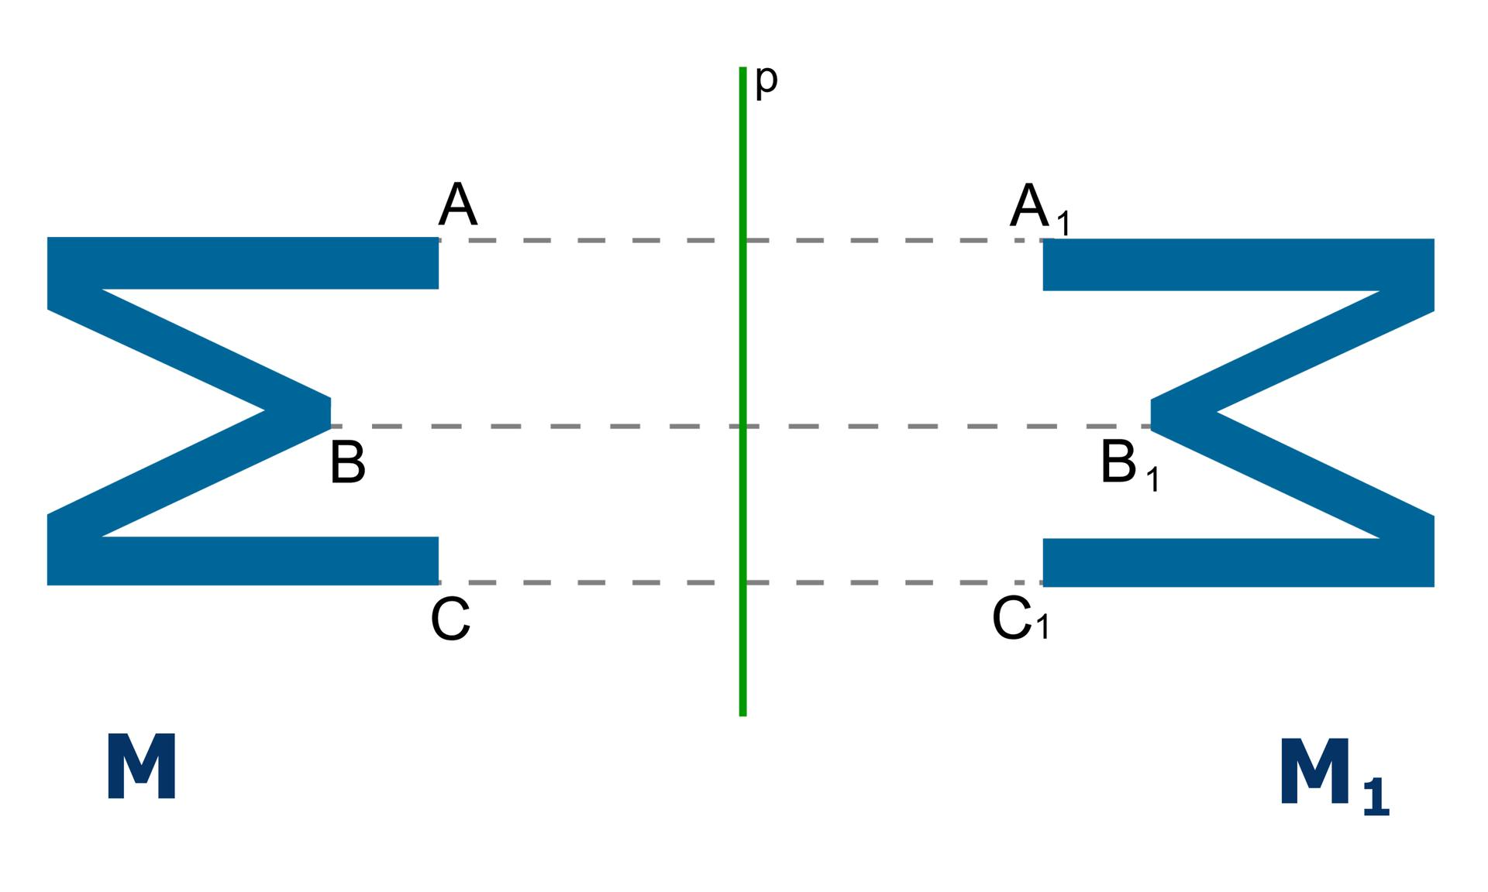
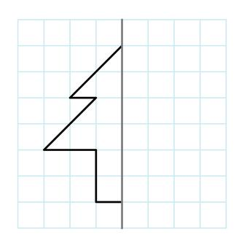
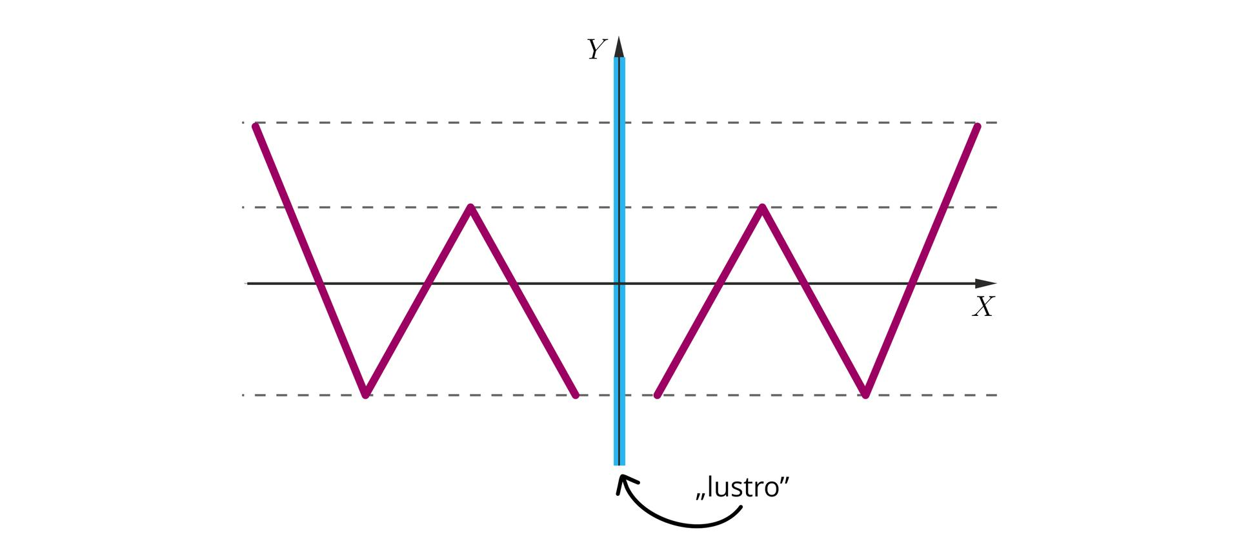
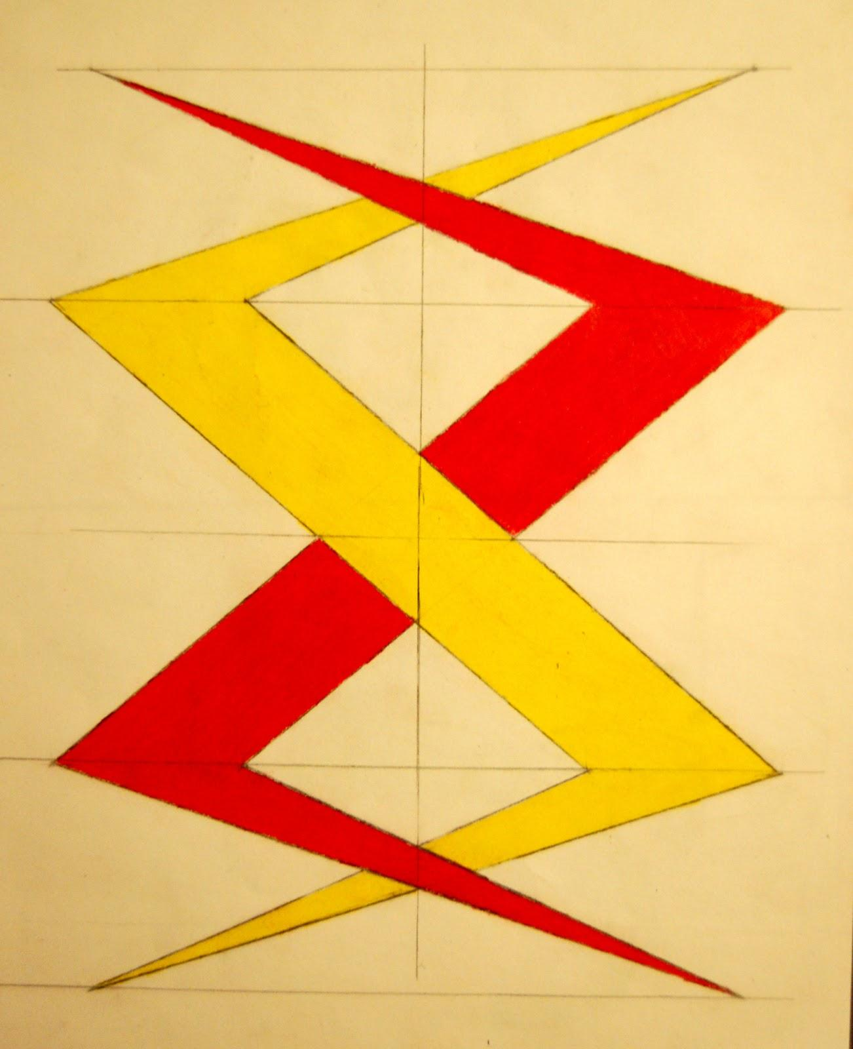

Definition
# Source: AI Source: Provided by: [Data Path: Persons Table -> ID Column: 1, Name_En Column: Motasem Essam] -> From: [ChatGPT] on [7/25/2026]
A Symmetric Zigzag Shape is a zigzag shape that remains unchanged under a particular symmetry transformation.
The most common type is reflection symmetry, where one part of the zigzag is a mirror image of another part across a line of symmetry.
A symmetric zigzag can be regular or irregular, and it can be open or closed.

Fundamental Concept
# Source: AI Source: Provided by: [Data Path: Persons Table -> ID Column: 1, Name_En Column: Motasem Essam] -> From: [ChatGPT] on [7/25/2026]
A zigzag is symmetric when its geometric arrangement has a corresponding pattern on the other side of a symmetry axis or under another symmetry transformation.
For example:
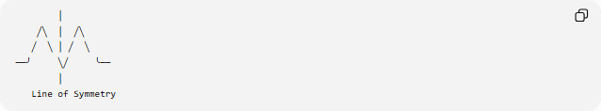
│
╱╲ │ ╱╲
╱ ╲ │ ╱ ╲
──╯ ╲╱ ╰──
│
Line of Symmetry
The two sides correspond to each other through reflection.
Mathematically, if a reflection transformation $R$maps the shape $S$onto itself:
$$\boxed{R\left(S\right)=S}$$
then the shape has reflection symmetry.

Main Characteristics
# Source: AI Source: Provided by: [Data Path: Persons Table -> ID Column: 1, Name_En Column: Motasem Essam] -> From: [ChatGPT] on [7/25/2026]
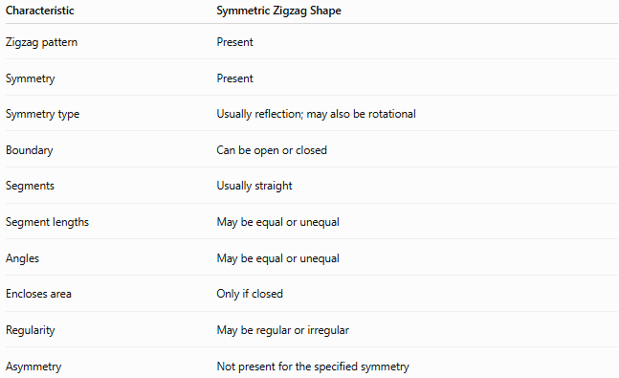
Characteristic | Symmetric Zigzag Shape
Zigzag pattern | Present
Symmetry | Present
Symmetry type | Usually reflection; may also be rotational
Boundary | Can be open or closed
Segments | Usually straight
Segment lengths | May be equal or unequal
Angles | May be equal or unequal
Encloses area | Only if closed
Regularity | May be regular or irregular
Asymmetry | Not present for the specified symmetry

Types of Symmetric Zigzag Shapes
# Source: AI Source: Provided by: [Data Path: Persons Table -> ID Column: 1, Name_En Column: Motasem Essam] -> From: [ChatGPT] on [7/25/2026]
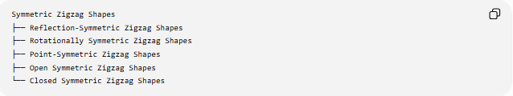
Symmetric Zigzag Shapes
├── Reflection-Symmetric Zigzag Shapes
├── Rotationally Symmetric Zigzag Shapes
├── Point-Symmetric Zigzag Shapes
├── Open Symmetric Zigzag Shapes
└── Closed Symmetric Zigzag Shapes

1-Reflection-Symmetric Zigzag Shapes
# Source: AI Source: Provided by: [Data Path: Persons Table -> ID Column: 1, Name_En Column: Motasem Essam] -> From: [ChatGPT] on [7/25/2026]
A Reflection-Symmetric Zigzag Shape has at least one line of symmetry.
Reflection across that line maps the shape onto itself.
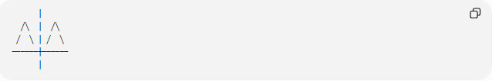
│
╱╲ │ ╱╲
╱ ╲ │ ╱ ╲
──────┼──────
│
The vertical line represents the axis of symmetry.
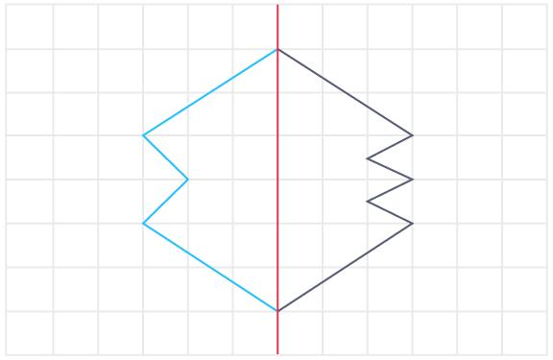
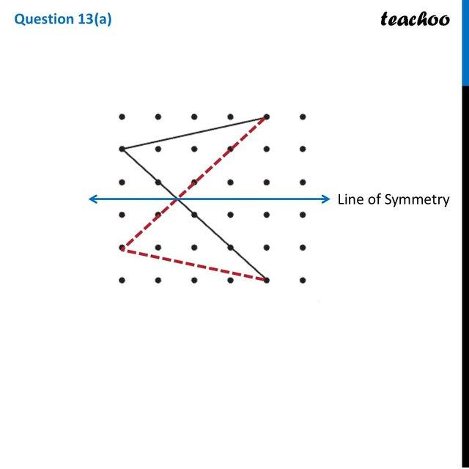
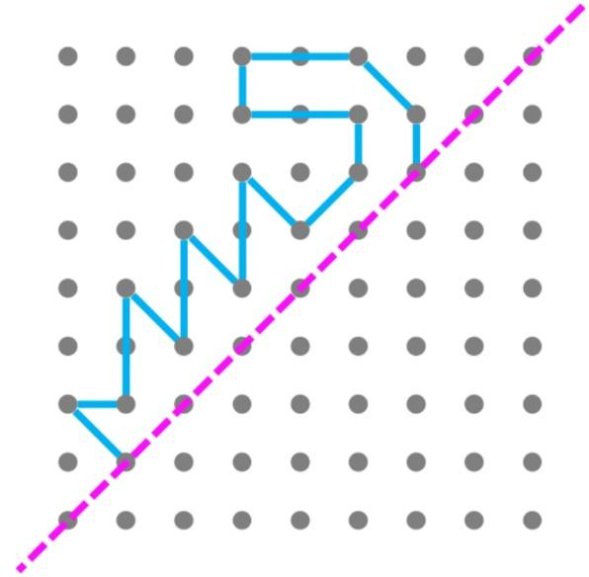

2-Rotationally Symmetric Zigzag Shapes
# Source: AI Source: Provided by: [Data Path: Persons Table -> ID Column: 1, Name_En Column: Motasem Essam] -> From: [ChatGPT] on [7/25/2026]
A Rotationally Symmetric Zigzag Shape matches itself after rotation through an angle smaller than ${360}^{∘}$.
If the rotational symmetry has order $n$, the smallest angle of rotation is:
$$\boxed{θ=\frac{{360}^{∘}}{n}}$$

3-Point-Symmetric Zigzag Shapes
# Source: AI Source: Provided by: [Data Path: Persons Table -> ID Column: 1, Name_En Column: Motasem Essam] -> From: [ChatGPT] on [7/25/2026]
A Point-Symmetric Zigzag Shape has 180° rotational symmetry.
Every point of the shape corresponds to another point on the opposite side of the center.
$$\boxed{θ={180}^{∘}}$$
Point symmetry is therefore a special case of rotational symmetry of order 2.

4-Open Symmetric Zigzag Shapes
# Source: AI Source: Provided by: [Data Path: Persons Table -> ID Column: 1, Name_En Column: Motasem Essam] -> From: [ChatGPT] on [7/25/2026]
An open zigzag can possess symmetry even though it does not enclose an area.
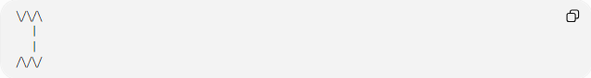
Example:
╲╱╲╱╲
│
│
╱╲╱╲╱
The path may be arranged symmetrically around a central axis.

5-Closed Symmetric Zigzag Shapes
# Source: AI Source: Provided by: [Data Path: Persons Table -> ID Column: 1, Name_En Column: Motasem Essam] -> From: [ChatGPT] on [7/25/2026]
A closed zigzag can have one or more symmetry transformations.
For example, a closed zigzag polygon can have reflection symmetry across a vertical axis.
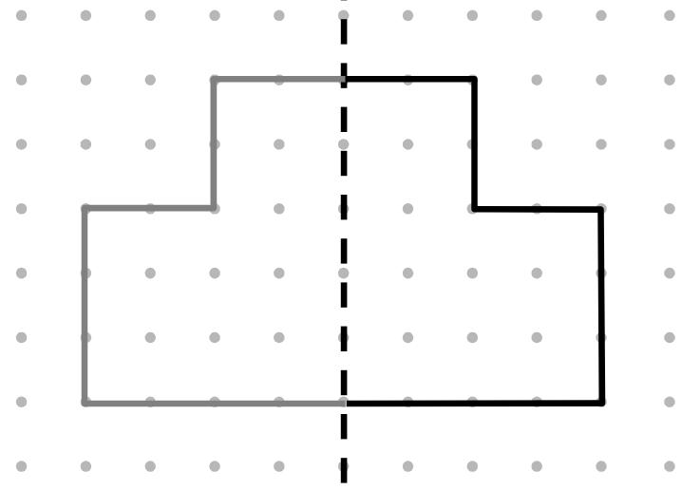
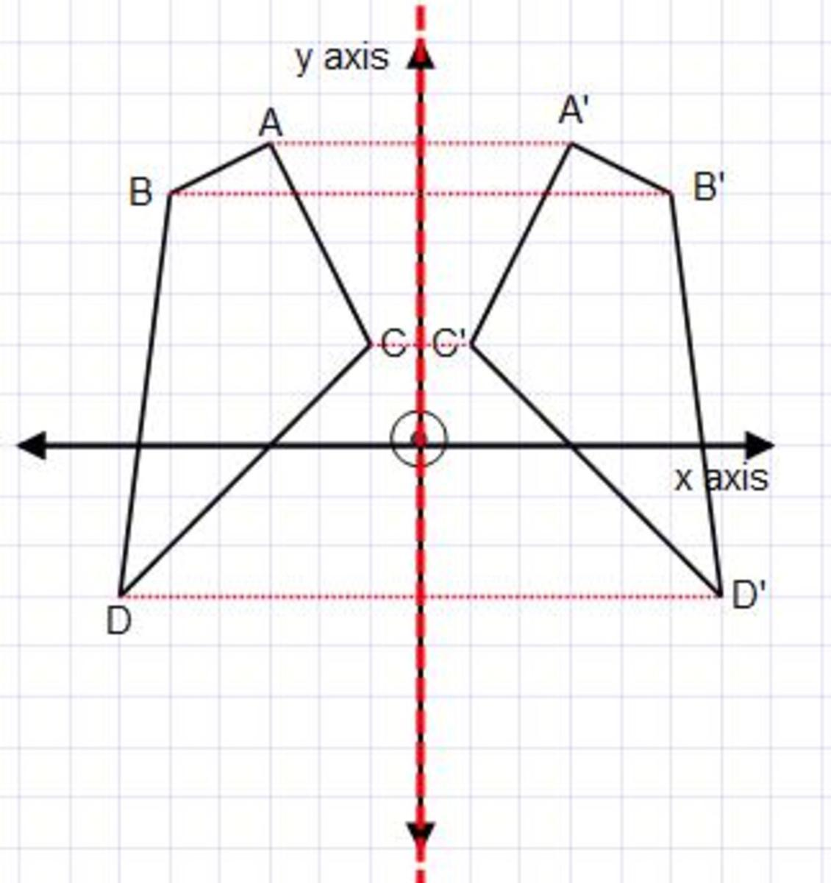
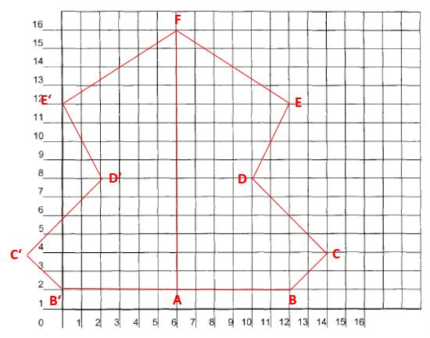

Symmetric Zigzag by Regularity
# Source: AI Source: Provided by: [Data Path: Persons Table -> ID Column: 1, Name_En Column: Motasem Essam] -> From: [ChatGPT] on [7/25/2026]
Symmetry and regularity are independent properties.
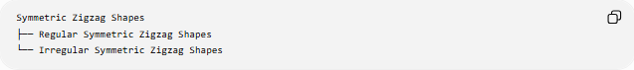
Symmetric Zigzag Shapes
├── Regular Symmetric Zigzag Shapes
└── Irregular Symmetric Zigzag Shapes
Regular Symmetric Zigzag
A regular zigzag follows a consistent geometric pattern and also has symmetry.
Irregular Symmetric Zigzag
An irregular zigzag can still have symmetry if corresponding parts mirror each other.
For example:
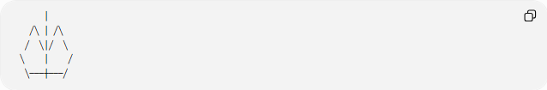
│
╱╲ │ ╱╲
╱ ╲│╱ ╲
╲ │ ╱
╲───┼───╱
The segment lengths do not necessarily have to be identical for the shape to have symmetry.

Mathematical Properties
# Source: AI Source: Provided by: [Data Path: Persons Table -> ID Column: 1, Name_En Column: Motasem Essam] -> From: [ChatGPT] on [7/25/2026]
Reflection Symmetry
For reflection across a vertical line $x=a$:
$$\boxed{\left(x , y\right)→\left(2 , a-xy\right)}$$
For reflection across the $y$-axis:
$$\boxed{\left(x , y\right)→\left(- , xy\right)}$$
Rotational Symmetry
For rotational symmetry of order $n$:
$$\boxed{θ=\frac{{360}^{∘}}{n}}$$
Point Symmetry
For a center of symmetry $\left(h , k\right)$, a point
$$\left(x , y\right)$$
corresponds to:
$$\boxed{\left(2 , h-x 2k-y\right)}$$

Symmetric vs. Asymmetric Zigzag Shapes
# Source: AI Source: Provided by: [Data Path: Persons Table -> ID Column: 1, Name_En Column: Motasem Essam] -> From: [ChatGPT] on [7/25/2026]
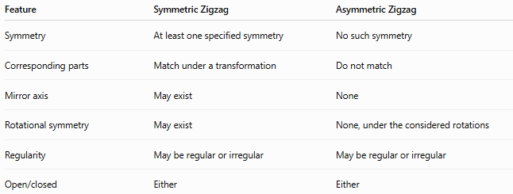
Feature | Symmetric Zigzag | Asymmetric Zigzag
Symmetry | At least one specified symmetry | No such symmetry
Corresponding parts | Match under a transformation | Do not match
Mirror axis | May exist | None
Rotational symmetry | May exist | None, under the considered rotations
Regularity | May be regular or irregular | May be regular or irregular
Open/closed | Either | Either
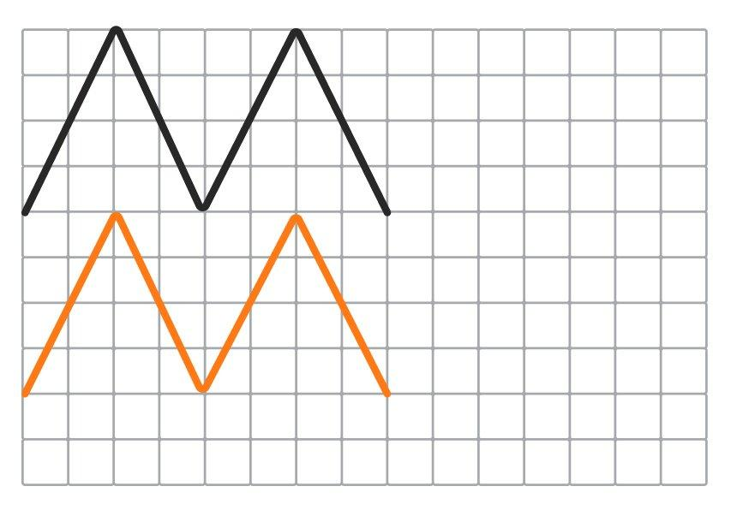
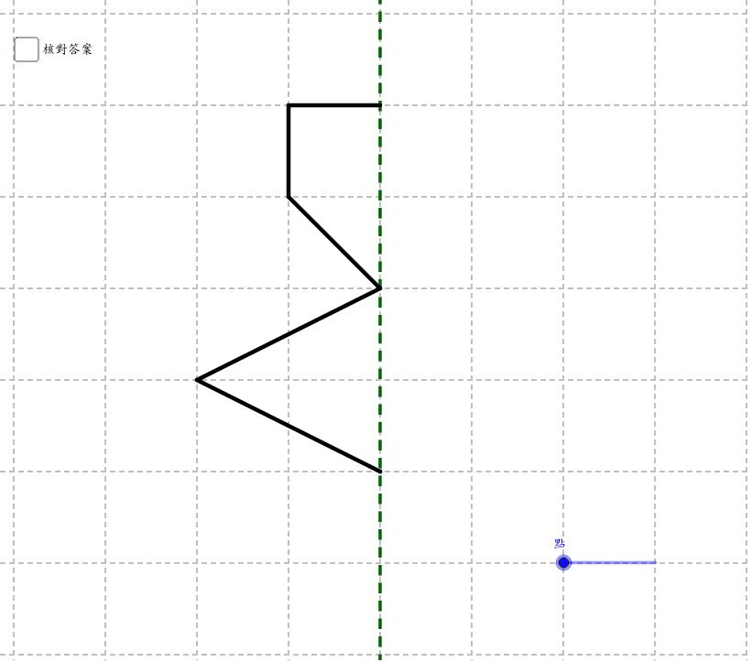

Symmetric Zigzag vs. Regular Zigzag
# Source: AI Source: Provided by: [Data Path: Persons Table -> ID Column: 1, Name_En Column: Motasem Essam] -> From: [ChatGPT] on [7/25/2026]
These terms describe different properties.
- Symmetric describes how a shape relates to a transformation.
- Regular describes the consistency of its geometric pattern.
Therefore:
$$\boxed{\text{Symmetric}≠\text{Regular}}$$
A zigzag may be:
- symmetric and regular,
- symmetric and irregular,
- asymmetric and irregular.

Examples

Example 1 – Reflection-Symmetric Open Zigzag
# Source: AI Source: Provided by: [Data Path: Persons Table -> ID Column: 1, Name_En Column: Motasem Essam] -> From: [ChatGPT] on [7/25/2026]
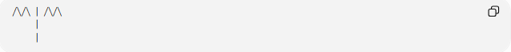
╱╲╱╲ │ ╱╲╱╲
│
│
The two sides correspond through reflection.

Example 2 – Symmetric Closed Zigzag
# Source: AI Source: Provided by: [Data Path: Persons Table -> ID Column: 1, Name_En Column: Motasem Essam] -> From: [ChatGPT] on [7/25/2026]
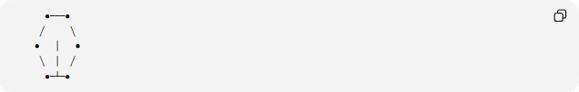
●───●
╱ ╲
● │ ●
╲ │ ╱
●─┴─●
The vertical axis can act as a line of symmetry.

Example 3 – Point-Symmetric Zigzag
# Source: AI Source: Provided by: [Data Path: Persons Table -> ID Column: 1, Name_En Column: Motasem Essam] -> From: [ChatGPT] on [7/25/2026]
A zigzag can also be arranged so that rotating it by ${180}^{∘}$produces the same shape.

Classification Summary
# Source: AI Source: Provided by: [Data Path: Persons Table -> ID Column: 1, Name_En Column: Motasem Essam] -> From: [ChatGPT] on [7/25/2026]
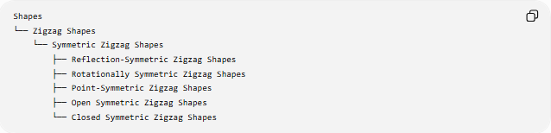
Shapes
└── Zigzag Shapes
└── Symmetric Zigzag Shapes
├── Reflection-Symmetric Zigzag Shapes
├── Rotationally Symmetric Zigzag Shapes
├── Point-Symmetric Zigzag Shapes
├── Open Symmetric Zigzag Shapes
└── Closed Symmetric Zigzag Shapes
Symmetry can overlap with other classifications:
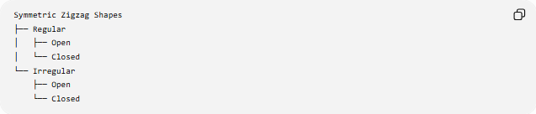
Symmetric Zigzag Shapes
├── Regular
│ ├── Open
│ └── Closed
└── Irregular
├── Open
└── Closed

Key Points
# Source: AI Source: Provided by: [Data Path: Persons Table -> ID Column: 1, Name_En Column: Motasem Essam] -> From: [ChatGPT] on [7/25/2026]
- A Symmetric Zigzag Shape has at least one symmetry transformation.
- Reflection symmetry is the most common type.
- A zigzag can also have rotational symmetry or point symmetry.
- A symmetric zigzag can be open or closed.
- A symmetric zigzag can be regular or irregular.
- Symmetry does not require all segments to have equal lengths.
- For rotational symmetry of order $n$:
$$\boxed{θ=\frac{{360}^{∘}}{n}}$$
- Point symmetry corresponds to a ${180}^{∘}$rotation.

Conclusion
# Source: AI Source: Provided by: [Data Path: Persons Table -> ID Column: 1, Name_En Column: Motasem Essam] -> From: [ChatGPT] on [7/25/2026]
A Symmetric Zigzag Shape is a zigzag whose arrangement is preserved by a specified symmetry transformation. Its symmetry may be produced by reflection, rotation, or a ${180}^{∘}$point symmetry. Symmetry is independent of whether the zigzag is regular, irregular, open, or closed.

